Explainable AI for Intrusion Detection Systems: LIME and SHAP Applicability on Multi-Layer Perceptron

ABSTRACT
Intrusion Detection Systems (IDS) play a pivotal role in ensuring network security by identifying malicious traffic and safeguarding against Advanced Persistent Threats (APTs). With the exponential rise of cyberattacks, machine learning (ML) and deep learning (DL) approaches have been widely adopted to improve intrusion detection accuracy. In this work, we present an Explainable Artificial Intelligence (XAI)-based framework for intrusion detection using the CIC-IDS dataset. Two state-of-the-art deep learning models, Long Short-Term Memory (LSTM) and Temporal Convolutional Network (TCN), were implemented and compared in terms of precision, recall, F-score, accuracy, confusion matrix, and ROC curve. To evaluate model robustness, perturbations were added to the test data, simulating real-world unknown attacks. Remarkably, both algorithms sustained high accuracy, achieving more than 98%, with LSTM outperforming TCN at 99.88%. The explainability aspect was incorporated using SHAP (SHapley Additive exPlanations), which provided insights into feature importance and contribution toward prediction. SHAP summary and violin plots highlighted critical network traffic attributes influencing classification, thereby enhancing model transparency and trustworthiness for cybersecurity applications. The system was implemented as an interactive GUI-based application comprising modules for dataset upload, preprocessing, model training, algorithm execution, performance comparison, and XAI-based model interpretation. The experimental results demonstrate the efficacy of LSTM and TCN in intrusion detection, with LSTM providing superior performance. Moreover, the inclusion of explainable AI bridges the gap between black-box DL models and human interpretability, which is vital for cybersecurity experts in decision-making processes. This study confirms that integrating robust deep learning architectures with explainable AI significantly enhances the accuracy, interpretability, and practical applicability of IDS in detecting sophisticated intrusions.
Keywords:
Intrusion Detection System, Explainable AI, LSTM, TCN, SHAP, CIC-IDS, Deep Learning, Cybersecurity

INTRODUCTION
In today's digital age, cybersecurity has emerged as a paramount concern for organizations and individuals alike. As cyberattacks continue to evolve in sophistication and frequency, the need for intelligent, adaptive, and interpretable Intrusion Detection Systems (IDS) has never been more critical. Traditional rule-based IDS are becoming increasingly inadequate in detecting zero-day or unknown attacks due to their static nature. To address this challenge, machine learning (ML) and deep learning (DL) techniques have been widely adopted, offering dynamic and scalable solutions capable of learning complex patterns from network traffic data.
Among the many advancements in AI-driven IDS, two significant models stand out: Long Short-Term Memory (LSTM) networks and Temporal Convolutional Networks (TCN). LSTM, a type of recurrent neural network (RNN), is well-known for its ability to capture long-term dependencies in sequential data, making it highly suitable for network intrusion detection where temporal relationships exist. TCNs, on the other hand, provide a novel approach by using causal convolutions and dilation to model sequence data with greater parallelism and stability in training compared to RNN-based architectures.
This project leverages both LSTM and TCN algorithms to predict and detect network intrusions using the well-known CICIDS 2017 dataset. The CICIDS dataset is recognized for its realistic traffic patterns and comprehensive representation of both normal and malicious network behavior, including various attack types such as DoS, DDoS, Port Scanning, and more. The dataset was first cleaned and pre-processed, including the handling of missing values, encoding categorical features into numerical form, and applying normalization techniques such as StandardScaler to bring features to a comparable scale. The processed dataset was then split into an 80-20 ratio for training and testing, respectively.
Once both LSTM and TCN models were trained and tested on this dataset, their performance was evaluated using key classification metrics: accuracy, precision, recall, F1-score, confusion matrix, and ROC (Receiver Operating Characteristic) curves. To challenge model robustness and simulate real-world conditions, a perturbation was introduced to the test data. Despite this, both models maintained high accuracy, exceeding 98%, proving their reliability in detecting intrusions even under adversarial conditions.

While model performance is crucial, the ability to interpret model decisions is equally important, especially in high-stakes domains like cybersecurity. Hence, this project incorporates Explainable AI (XAI) techniques, specifically SHapley Additive exPlanations (SHAP), to offer insights into model predictions. SHAP values quantify the contribution of each input feature to a model's prediction, allowing security analysts to understand which features led the model to classify a network packet as an attack or normal behavior. This level of transparency not only improves trust in AI systems but also aids in faster incident response and root cause analysis.
Although LIME (Local Interpretable Model-agnostic Explanations) is another powerful XAI tool, this project focuses on SHAP due to its ability to offer both global and local explanations, and its stronger theoretical foundation grounded in cooperative game theory. SHAP's summary and violin plots were used to visualize feature importance, offering intuitive explanations for both models' decisions.
The project was developed as a GUI-based tool, consisting of various modules such as data upload, preprocessing, model training, comparison graphs, SHAP-based model explanations, and real-time intrusion prediction from uploaded test data. Users can interact with the application through a simple interface where each module can be executed by the click of a button, enhancing accessibility for non-technical users or cybersecurity professionals.
In conclusion, this project demonstrates the successful application of deep learning and explainable AI in building an effective, robust, and interpretable intrusion detection system. By combining the predictive power of LSTM and TCN with the interpretability of SHAP, it bridges the gap between model accuracy and model transparency—an essential step towards trustworthy AI in cybersecurity. The modular and interactive nature of the application also makes it scalable and adaptable for integration into larger security infrastructures.
Objective of the project:
- Develop a Deep Learning-based Intrusion Detection System (IDS) using LSTM and TCN models trained on the CICIDS dataset.
- Evaluate and Compare Model Performance using metrics like accuracy, precision, recall, F1-score, confusion matrix, and ROC curves.
- Introduce Data Perturbation to test the robustness and generalization ability of the trained models on unknown or adversarial data.
- Apply Explainable AI Tools (SHAP) to interpret model decisions and highlight the features contributing most to predictions.
- Design a User-friendly GUI Interface for seamless dataset upload, model training, result visualization, and intrusion prediction.

LITERATURE SURVEY:
“A Deep Learning Approach for Network Intrusion Detection System”
A. Javaid, Q. Niyaz, W. Sun, M. Alam, 2016
This paper presented a deep learning-based IDS using unsupervised feature learning and deep neural networks. It demonstrated higher detection accuracy than traditional methods but highlighted the black-box nature of deep learning models as a limitation.

“Toward Generating a New Intrusion Detection Dataset and Intrusion Traffic Characterization”
I. Sharafaldin, A. H. Lashkari, A. A. Ghorbani, 2018
The authors developed the CIC-IDS2017 dataset to provide realistic and diverse attack scenarios for IDS research. The dataset has since become a benchmark for evaluating deep learning-based IDS models.

“Applying LSTM to Anomaly Detection in Network Traffic”
J. Kim, H. Kim, 2019
This work applied Long Short-Term Memory (LSTM) networks to detect anomalies in network traffic. The study showed that LSTM models effectively captured sequential dependencies, outperforming traditional machine learning methods.

“An Empirical Evaluation of Generic Convolutional and Recurrent Networks for Sequence Modeling”
S. Bai, J. Z. Kolter, V. Koltun, 2018
The authors compared Temporal Convolutional Networks (TCN) with LSTMs and RNNs across multiple sequence modeling tasks. Results showed that TCNs offered stable gradients and parallelism, making them suitable for IDS applications.

“Why Should I Trust You? Explaining the Predictions of Any Classifier”
M. T. Ribeiro, S. Singh, C. Guestrin, 2016
This paper introduced LIME, an explainable AI technique that provides local, interpretable explanations for any machine learning classifier. It emphasized the importance of transparency in decision-critical applications like cybersecurity.

“A Unified Approach to Interpreting Model Predictions”
S. M. Lundberg, S. I. Lee, 2017
The authors proposed SHAP, a game-theoretic method to explain machine learning models by computing feature contributions. SHAP has since been widely adopted in security systems to interpret model decisions.

“Survey of Intrusion Detection Systems: Techniques, Datasets, and Challenges”
A. Khraisat, I. Gondal, P. Vamplew, J. Kamruzzaman, 2019
This survey reviewed IDS techniques, highlighting strengths and weaknesses of machine learning and deep learning approaches. It also emphasized challenges like high false alarm rates and lack of interpretability in IDS models.

“Explainable Deep Learning in Network Intrusion Detection: A Review”
J. Zhang, M. Zulkernine, 2021
The study focused on integrating explainable AI with IDS, reviewing techniques like SHAP and LIME for enhancing trust in predictions. It concluded that explainability is essential for deploying IDS in real-world security-critical environments.
“Enhancing Intrusion Detection with Explainable AI: A Case Study Using SHAP”
Y. Yu, J. Long, 2022
This paper explored the integration of SHAP with deep learning-based intrusion detection systems to interpret feature contributions. The study demonstrated that SHAP explanations help identify critical network features influencing attack detection, improving model transparency and analyst trust.

3. SYSTEM ANALYSIS
3.1 EXISTING SYSTEM:
The existing intrusion detection systems rely heavily on traditional machine learning algorithms or shallow models such as Decision Trees, Naïve Bayes, and Support Vector Machines. These approaches, although effective in some cases, often fail to capture the complex temporal dependencies and sequential patterns present in large-scale network traffic. Moreover, most of these models act as black-box predictors without providing clear reasoning or interpretability behind their predictions. While they offer moderate accuracy, their robustness against adversarial attacks or perturbed test data remains limited, reducing their applicability in real-world dynamic intrusion environments.
Disadvantages
- Limited ability to capture temporal and sequential dependencies in network traffic.
- Lack of robustness when tested against unseen or perturbed data.
- Poor interpretability, making them less reliable for expert decision-making.
3.2 PROPOSED SYSTEM:
The proposed system introduces advanced deep learning models—LSTM and TCN—trained on the CIC-IDS dataset for intrusion detection. Both models are evaluated on pre-processed, normalized datasets, achieving accuracy beyond 98% even under perturbed test conditions. Additionally, explainability is integrated through SHAP, which identifies feature importance and highlights how specific network attributes contribute to prediction outcomes. This improves not only detection accuracy but also model transparency, enabling security analysts to trust and validate the results. A GUI-based interactive framework is implemented for seamless execution of modules, comparison of results, and visualization of SHAP-based explanations, ensuring both robustness and interpretability.
Advantages
- Achieves superior accuracy (up to 99.88%) with LSTM, even under perturbed test scenarios.
- Provides explainability using SHAP, enhancing model trust and transparency.
- GUI-based implementation offers user-friendly interaction, real-time analysis, and better decision support.
SYSTEM ARCHITECTURE:
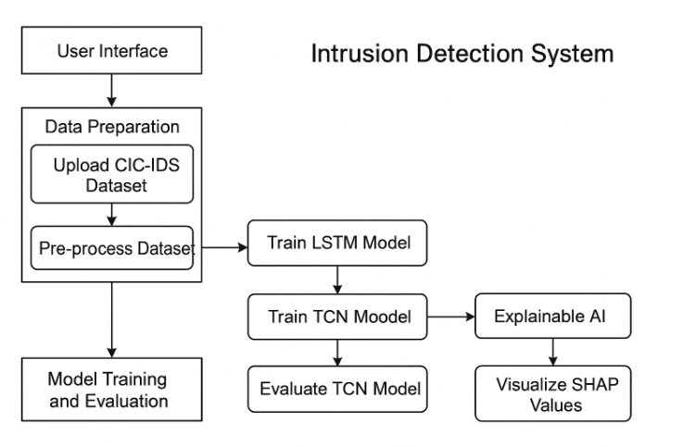

FLOW CHART DIAGRAM:
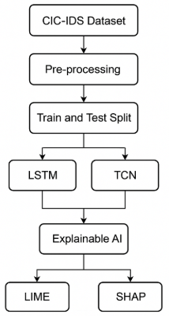
Modules Description:
To Implement this project Author is used these Following Modules:
- Upload CICIDS Dataset: using this module we will upload dataset details and then application will read and display dataset values and then find and plot graph of normal and attack count
- Pre-process Dataset: using this module we will apply pre-process technique on dataset to remove missing values and then convert all non-numeric data into numeric data
- Train & Test Split: using this module will split dataset into train and test where application using 80% dataset for training and 20% for testing
- Run LSTM Algorithm: using this module we will input 80% dataset to LSTM to train a model and 20% test data will be applied on trained model to calculate prediction accuracy
- Run TCN Algorithm: using this module we will input 80% dataset to TCN to train a model and 20% test data will be applied on trained model to calculate prediction accuracy
- Comparison Graph: using this module we will plot accuracy comparison graph between all algorithms
- Summary Model Explanation: using this module will explain model performance using summary plot which will show which features contribute most for correct prediction
- Violin Model Explanation: using this module will explain model performance using violin plot which will show which features contribute most for correct prediction
- Predict Attack from Test Data: using this module we will upload test data and then LSTM model will analyse dataset and then predict weather dataset contains normal or attack features
3.3. PROCESS MODEL USED WITH JUSTIFICATION
SDLC (Umbrella Model):
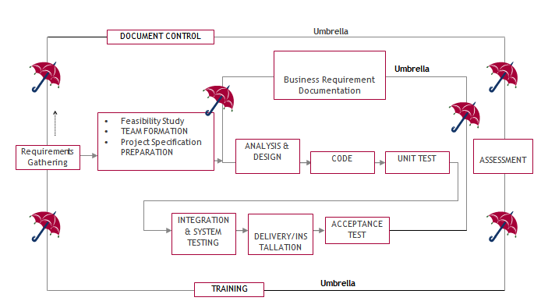

SDLC is nothing but Software Development Life Cycle. It is a standard which is used by software industry to develop good software.

Stages in SDLC:
- Requirement Gathering
- Analysis
- Designing
- Coding
- Testing
- Maintenance

Requirements Gathering stage:
The requirements gathering process takes as its input the goals identified in the high-level requirements section of the project plan. Each goal will be refined into a set of one or more requirements. These requirements define the major functions of the intended application, define operational data areas and reference data areas, and define the initial data entities. Major functions include critical processes to be managed, as well as mission critical inputs, outputs and reports. A user class hierarchy is developed and associated with these major functions, data areas, and data entities. Each of these definitions is termed a Requirement. Requirements are identified by unique requirement identifiers and, at minimum, contain a requirement title and textual description.
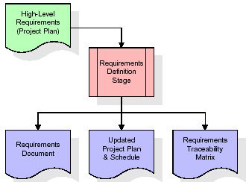
These requirements are fully described in the primary deliverables for this stage: the Requirements Document and the Requirements Traceability Matrix (RTM). The requirements document contains complete descriptions of each requirement, including diagrams and references to external documents as necessary. Note that detailed listings of database tables and fields are not included in the requirements document.
The title of each requirement is also placed into the first version of the RTM, along with the title of each goal from the project plan. The purpose of the RTM is to show that the product components developed during each stage of the software development lifecycle are formally connected to the components developed in prior stages.
In the requirements stage, the RTM consists of a list of high-level requirements, or goals, by title, with a listing of associated requirements for each goal, listed by requirement title. In this hierarchical listing, the RTM shows that each requirement developed during this stage is formally linked to a specific product goal. In this format, each requirement can be traced to a specific product goal, hence the term requirements traceability.
The outputs of the requirements definition stage include the requirements document, the RTM, and an updated project plan.
- Feasibility study is all about identification of problems in a project.
- No. of staff required to handle a project is represented as Team Formation, in this case only modules are individual tasks will be assigned to employees who are working for that project.
- Project Specifications are all about representing of various possible inputs submitting to the server and corresponding outputs along with reports maintained by administrator.

Analysis Stage:
The planning stage establishes a bird's eye view of the intended software product, and uses this to establish the basic project structure, evaluate feasibility and risks associated with the project, and describe appropriate management and technical approaches.
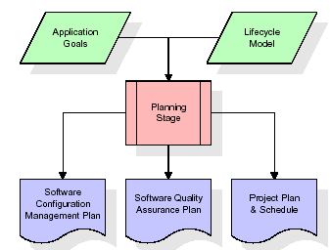
The most critical section of the project plan is a listing of high-level product requirements, also referred to as goals. All of the software product requirements to be developed during the requirements definition stage flow from one or more of these goals. The minimum information for each goal consists of a title and textual description, although additional information and references to external documents may be included. The outputs of the project planning stage are the configuration management plan, the quality assurance plan, and the project plan and schedule, with a detailed listing of scheduled activities for the upcoming Requirements stage, and high level estimates of effort for the out stages.

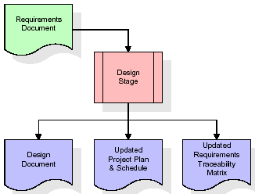
Designing Stage:
The design stage takes as its initial input the requirements identified in the approved requirements document. For each requirement, a set of one or more design elements will be produced as a result of interviews, workshops, and/or prototype efforts. Design elements describe the desired software features in detail, and generally include functional hierarchy diagrams, screen layout diagrams, tables of business rules, business process diagrams, pseudo code, and a complete entity-relationship diagram with a full data dictionary. These design elements are intended to describe the software in sufficient detail that skilled programmers may develop the software with minimal additional input.
When the design document is finalized and accepted, the RTM is updated to show that each design element is formally associated with a specific requirement. The outputs of the design stage are the design document, an updated RTM, and an updated project plan.
Development (Coding) Stage:
The development stage takes as its primary input the design elements described in the approved design document. For each design element, a set of one or more software artifacts will be produced. Software artifacts include but are not limited to menus, dialogs, and data management forms, data reporting formats, and specialized procedures and functions. Appropriate test cases will be developed for each set of functionally related software artifacts, and an online help system will be developed to guide users in their interactions with the software.
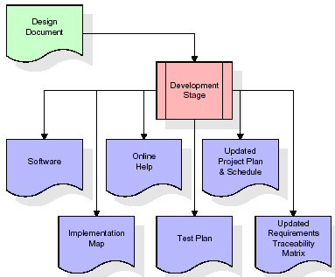

The RTM will be updated to show that each developed artifact is linked to a specific design element, and that each developed artifact has one or more corresponding test case items. At this point, the RTM is in its final configuration. The outputs of the development stage include a fully functional set of software that satisfies the requirements and design elements previously documented, an online help system that describes the operation of the software, an implementation map that identifies the primary code entry points for all major system functions, a test plan that describes the test cases to be used to validate the correctness and completeness of the software, an updated RTM, and an updated project plan.
Integration & Test Stage:
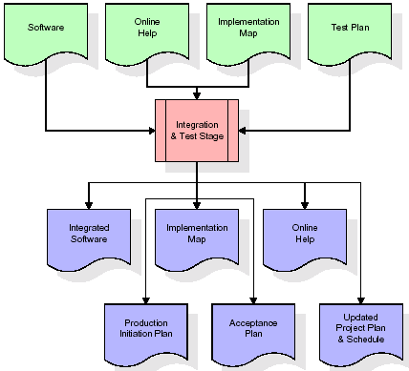
During the integration and test stage, the software artifacts, online help, and test data are migrated from the development environment to a separate test environment. At this point, all test cases are run to verify the correctness and completeness of the software. Successful execution of the test suite confirms a robust and complete migration capability. During this stage, reference data is finalized for production use and production users are identified and linked to their appropriate roles. The final reference data (or links to reference data source files) and production user list are compiled into the Production Initiation Plan.

The outputs of the integration and test stage include an integrated set of software, an online help system, an implementation map, a production initiation plan that describes reference data and production users, an acceptance plan which contains the final suite of test cases, and an updated project plan.
- Installation & Acceptance Test:
During the installation and acceptance stage, the software artifacts, online help, and initial production data are loaded onto the production server. At this point, all test cases are run to verify the correctness and completeness of the software. Successful execution of the test suite is a prerequisite to acceptance of the software by the customer.
After customer personnel have verified that the initial production data load is correct and the test suite has been executed with satisfactory results, the customer formally accepts the delivery of the software.
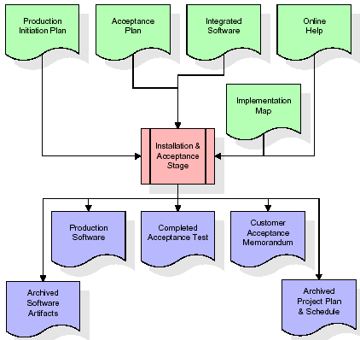
The primary outputs of the installation and acceptance stage include a production application, a completed acceptance test suite, and a memorandum of customer acceptance of the software. Finally, the PDR enters the last of the actual labor data into the project schedule and locks the project as a permanent project record. At this point the PDR "locks" the project by archiving all software items, the implementation map, the source code, and the documentation for future reference.
Maintenance:
Outer rectangle represents maintenance of a project, Maintenance team will start with requirement study, understanding of documentation later employees will be assigned work and they will undergo training on that particular assigned category. For this life cycle there is no end, it will be continued so on like an umbrella (no ending point to umbrella sticks).

3.4. Software Requirement Specification
3.4.1. Overall Description
A Software Requirements Specification (SRS) – a requirements specification for a software system is a complete description of the behaviour of a system to be developed. It includes a set of use cases that describe all the interactions the users will have with the software. In addition to use cases, the SRS also contains non-functional requirements. Non-functional requirements are requirements which impose constraints on the design or implementation (such as performance engineering requirements, quality standards, or design constraints).
System requirements specification: A structured collection of information that embodies the requirements of a system. A business analyst, sometimes titled system analyst, is responsible for analysing the business needs of their clients and stakeholders to help identify business problems and propose solutions. Within the systems development lifecycle domain, the BA typically performs a liaison function between the business side of an enterprise and the information technology department or external service providers. Projects are subject to three sorts of requirements:
- Business requirements describe in business terms what must be delivered or accomplished to provide value.
- Product requirements describe properties of a system or product (which could be one of several ways to accomplish a set of business requirements.)
- Process requirements describe activities performed by the developing organization. For instance, process requirements could specify .Preliminary investigation examine project feasibility, the likelihood the system will be useful to the organization. The main objective of the feasibility study is to test the Technical, Operational and Economical feasibility for adding new modules and debugging old running system. All system is feasible if they are unlimited resources and infinite time. There are aspects in the feasibility study portion of the preliminary investigation:
- ECONOMIC FEASIBILITY
A system can be developed technically and that will be used if installed must still be a good investment for the organization. In the economic feasibility, the development cost in creating the system is evaluated against the ultimate benefit derived from the new systems. Financial benefits must equal or exceed the costs. The system is economically feasible. It does not require any addition hardware or software. Since the interface for this system is developed using the existing resources and technologies available at NIC, there is nominal expenditure and economical feasibility for certain.
- Operational Feasibility
Proposed projects are beneficial only if they can be turned out into information system. That will meet the organization’s operating requirements. Operational feasibility aspects of the project are to be taken as an important part of the project implementation. This system is targeted to be in accordance with the above-mentioned issues. Beforehand, the management issues and user requirements have been taken into consideration. So there is no question of resistance from the users that can undermine the possible application benefits. The well-planned design would ensure the optimal utilization of the computer resources and would help in the improvement of performance status.
- TECHNICAL FEASIBILITY
Earlier no system existed to cater to the needs of ‘Secure Infrastructure Implementation System’. The current system developed is technically feasible. It is a web-based user interface for audit workflow at NIC-CSD. Thus, it provides an easy access to. the users. The database’s purpose is to create, establish and maintain a workflow among various entities in order to facilitate all concerned users in their various capacities or roles. Permission to the users would be granted based on the roles specified. Therefore, it provides the technical guarantee of accuracy, reliability and security.

3.4.2. External Interface Requirements
User Interface
The user interface of this system is a user friendly python Graphical User Interface.
Hardware Interfaces
The interaction between the user and the console is achieved through python capabilities.
Software Interfaces
The required software is python.

SYSTEM REQUIREMENT:
HARDWARE REQUIREMENTS:

Processor - Intel I3(min)
- Speed - 1.1 GHz
- RAM - 4GB(min)
- Hard Disk - 500GB(min)
SOFTWARE REQUIREMENTS:
- Operating System - Windows 10/above
- Programming Language - Python 3.7.0

4. SYSTEM DESIGN
UML Diagram:
The Unified Modelling Language allows the software engineer to express an analysis model using the modelling notation that is governed by a set of syntactic semantic and pragmatic rules.
A UML system is represented using five different views that describe the system from distinctly different perspective. Each view is defined by a set of diagram, which is as follows.
  - User Model View
    - This view represents the system from the users perspective.
    - The analysis representation describes a usage scenario from the end-users perspective.
  - Structural Model view
    - In this model the data and functionality are arrived from inside the system.
    - This model view models the static structures.
- Behavioural Model View
It represents the dynamic of behavioural as parts of the system, depicting the interactions of collection between various structural elements described in the user model and structural model view.
- Implementation Model View
In this the structural and behavioural as parts of the system are represented as they are to be built.
- Environmental Model View
In this the structural and behavioural aspects of the environment in which the system is to be implemented are represented.
Class Diagram:
The class diagram is the main building block of object orientedmodeling. It is used both for general conceptual modeling of the systematic of the application, and for detailed modeling translating the models into programming code. Class diagrams can also be used for data modeling. The classes in a class diagram represent both the main objects, interactions in the application and the classes to be programmed. In the diagram, classes are represented with boxes which contain three parts:
- The upper part holds the name of the class
- The middle part contains the attributes of the class
- The bottom part gives the methods or operations the class can take or undertake.
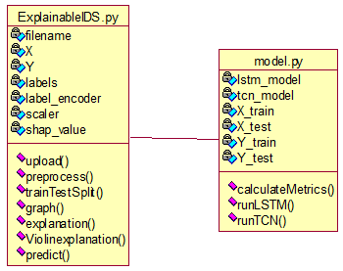
Use case Diagram:
A use case diagram at its simplest is a representation of a user's interaction with the system and depicting the specifications of a use case. A use case diagram can portray the different types of users of a system and the various ways that they interact with the system. This type of diagram is typically used in conjunction with the textual use case and will often be accompanied by other types of diagrams as well.
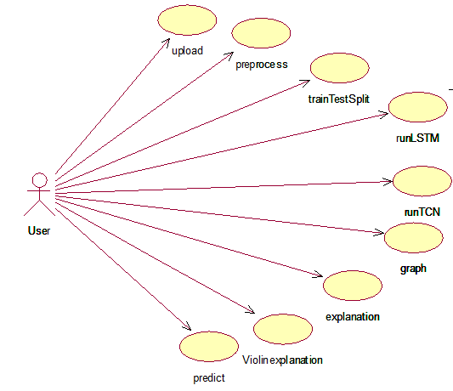
Sequence diagram:
A sequence diagram is a kind of interaction diagram that shows how processes operate with one another and in what order. It is a construct of a Message Sequence Chart. A sequence diagram shows object interactions arranged in time sequence. It depicts the objects and classes involved in the scenario and the sequence of messages exchanged between the objects needed to carry out the functionality of the scenario. Sequence diagrams are typically associated with use case realizations in the Logical View of the system under development. Sequence diagrams are sometimes called event diagrams, event scenarios, and timing diagrams.

Collaboration diagram:
A collaboration diagram describes interactions among objects in terms of sequenced messages. Collaboration diagrams represent a combination of information taken from class, sequence, and use case diagrams describing both the static structure and dynamic behaviour of a system.

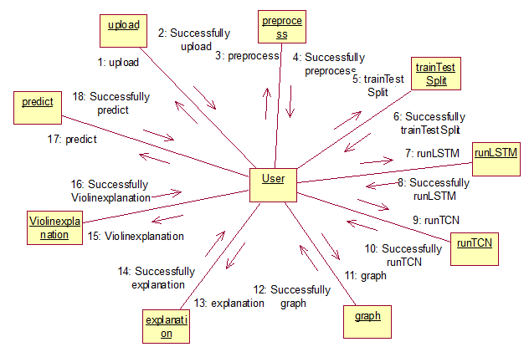
Component Diagram:
In the Unified Modelling Language, a component diagram depicts how components are wired together to form larger components and or software systems. They are used to illustrate the structure of arbitrarily complex systems.
Components are wired together by using an assembly connector to connect the required interface of one component with the provided interface of another component. This illustrates the service consumer - service provider relationship between the two components.

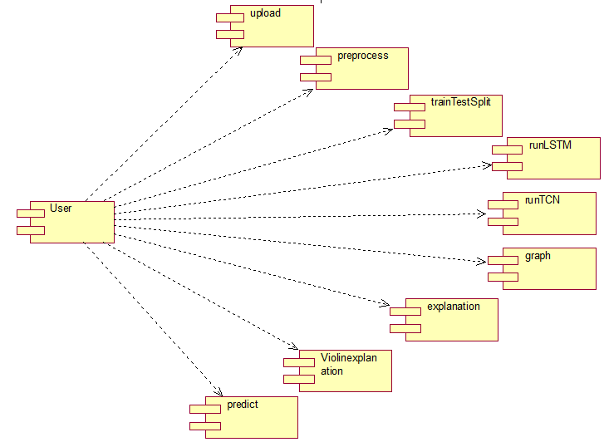

Deployment Diagram:
A deployment diagram in the Unified Modeling Language models the physical deployment of artifacts on nodes. To describe a web site, for example, a deployment diagram would show what hardware components ("nodes") exist (e.g., a web server, an application server, and a database server), what software components ("artifacts") run on each node (e.g., web application, database), and how the different pieces are connected (e.g. JDBC, REST, RMI).
The nodes appear as boxes, and the artifacts allocated to each node appear as rectangles within the boxes. Nodes may have sub nodes, which appear as nested boxes. A single node in a deployment diagram may conceptually represent multiple physical nodes, such as a cluster of database servers.
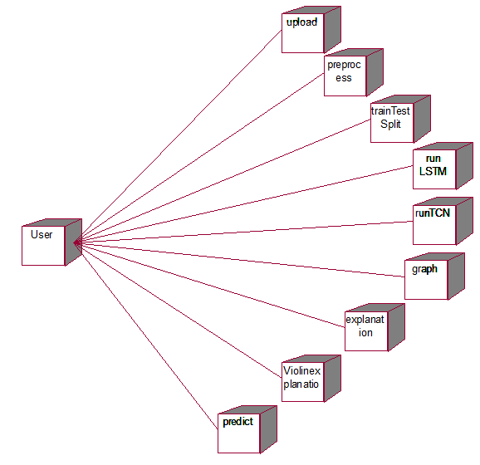
Activity Diagram:
Activity diagram is another important diagram in UML to describe dynamic aspects of the system. It is basically a flow chart to represent the flow form one activity to another
activity. The activity can be described as an operation of the system. So the control flow is drawn from one operation to another. This flow can be sequential, branched or concurrent
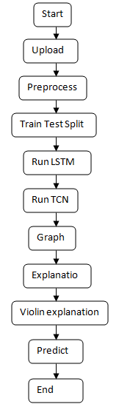
Data Flow Diagram:
Data flow diagrams illustrate how data is processed by a system in terms of inputs and outputs. Data flow diagrams can be used to provide a clear representation of any business function. The technique starts with an overall picture of the business and continues by analyzing each of the functional areas of interest. This analysis can be carried out in precisely the level of detail required. The technique exploits a method called top-down expansion to conduct the analysis in a targeted way.
As the name suggests, Data Flow Diagram (DFD) is an illustration that explicates the passage of information in a process. A DFD can be easily drawn using simple symbols. Additionally, complicated processes can be easily automated by creating DFDs using easy-to-use, free downloadable diagramming tools. A DFD is a model for constructing and analyzing information processes. DFD illustrates the flow of information in a process depending upon the inputs and outputs. A DFD can also be referred to as a Process Model. A DFD demonstrates business or technical process with the support of the outside data saved, plus the data flowing from the process to another and the end results.
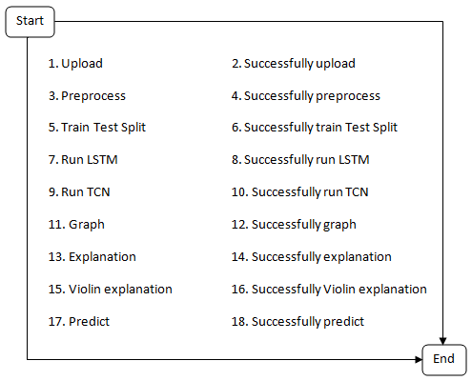
5. IMPLEMETATION
5.1 PYTHON
* One of the most popular languages is Python. Guido van Rossum released this language in 1991. Python is available on the Mac, Windows, and Raspberry Pi operating systems. The syntax of Python is simple and identical to that of English. When compared to Python, it was seen that the other language requires a few extra lines.
*It is an interpreter-based language because code may be run line by line after it has been written. This implies that rapid prototyping is possible across all platforms. Python is a big language with a free, binary-distributed interpreter standard library.
* It is inferior to maintenance that is conducted and is straightforward to learn. It is an object-oriented, interpreted programming language. It supports several different programming paradigms in addition to object-oriented programming, including functional and procedural programming.
* It supports several different programming paradigms in addition to object-oriented programming, including practical and procedural programming. Python is mighty while maintaining a relatively straightforward syntax. Classes, highly dynamic data types, modules, and exceptions are covered. Python can also be utilised by programmes that require programmable interfaces as an external language.
Here are some key features and characteristics of Python:
- Readability: Python emphasizes code readability with its clean and intuitive syntax. It uses indentation and whitespace to structure code blocks, making it easy to understand and maintain.
- Easy to Learn: Python's simplicity and readability make it an excellent choice for beginners. Its straightforward syntax and extensive documentation make it accessible for newcomers to programming.
- Interpreted Language: Python is an interpreted language, meaning that it doesn't need to be compiled before running. The Python interpreter reads and executes the code directly, making the development process faster and more interactive.
- Cross-platform Compatibility: Python is available for major operating systems like Windows, macOS, and Linux. This cross-platform compatibility allows developers to write code once and run it on different platforms without modifications.
- Large Standard Library: Python comes with a vast standard library that provides ready-to-use modules and functions for various tasks. It covers areas such as file I/O, networking, regular expressions, databases, and more, saving developers time and effort.
- Extensible and Modular: Python supports modular programming, enabling developers to organize code into reusable modules and packages. Additionally, Python allows integrating modules written in other languages, such as C or C++, providing flexibility and performance optimizations.
- Wide Range of Libraries and Frameworks: Python has a vibrant ecosystem with numerous third-party libraries and frameworks. These libraries, such as NumPy, pandas, TensorFlow, and Django, extend Python's capabilities for specific domains, making it a powerful tool for diverse applications.
- Object-Oriented: Python supports object-oriented programming (OOP) principles, allowing developers to create and work with classes and objects. OOP provides a structured approach to code organization, promoting code reuse and modularity.
- Dynamic Typing: Python is dynamically typed, meaning variable types are determined at runtime. Developers do not need to declare variable types explicitly, which enhances flexibility and simplifies code writing.
5.2 Installation
To install Python on your computer, follow these basic steps:
- Step 1: Visit the Python website Go to the official Python website at https://www.python.org/.
- Step 2: Select the operating system Choose the appropriate installer for your operating system. Python supports Windows, macOS, and various Linux distributions. Make sure to select the correct version that matches your operating system.
- Step 3: Check which version of Python is installed; if the 3.7.0 version is not there, uninstall it through the control panel and
- Step 4: Install Python 3.7.0 using Cmd.
- Step 5: Install the all libraries that required to run the project
- Step 6: Run
5.3 Python Features:
- Easy: Because Python is a more accessible and straightforward language, Python programming is easier to learn.
- Interpreted language: Python is an interpreted language;therefore it can be used to examine the code line by line and provide results.
- Open Source: Python is a free online programming language since it is open-source.
- Portable: Python is portable because the same code may be used on several computer standard
- libraries: Python offers a sizable library that we may utilize to create applications quickly.
- GUI: It stands for GUI (Graphical User Interface)
- Dynamical typed: Python is a dynamically typed language;therefore the type of the value will be determined at runtime.
5.4 Python GUI (Tkinter)
- Python provides a wide range of options for GUI development (Graphical User Interfaces).
- Tkinter, the most widely used GUI technique, is used for all of them.
- The Tk GUI toolkit offered by Python is used with the conventional Python interface.
- Tkinter is the easiest and quickest way to write Python GUI programs.
- Using Tkinter, creating a GUI is simple.
- A part of Python's built-in library is Tkinter. The GUI programs were created.
- Python and Tkinter together give a straightforward and quick way. The Tk GUI toolkit's object-oriented user interface is called Tkinter.

Making a GUI application is easy using Tkinter. Following are the steps:
1) Install the Tkinter module in place.
2) The GUI application Makes the primary window
3) Include one or more of the widgets mentioned above in the GUI application.
4) Set up the main event loop such that it reacts to each user-initiated event.
Although Tkinter is the only GUI framework included in the Python standard library, Python includes a GUI framework. The default library for Python is called Tkinter. Tk is a scripting language often used in designing, testing, and developing GUIs. Tk is a free, open-source widget toolkit that may be used to build GUI applications in a wide range of computer languages.
5.5 Python IDLE
- Python IDLE offers a full-fledged file editor, which gives you the ability to write and execute Python programs from within this program. The built-in file editor also includes several features, like code completion and automatic indentation, that will speed up your coding workflow.
- Guido Van Rossum named Python after the British comedy group Monty Python while the name IDLE was chosen to pay tribute to Eric Idle, who was one of the Monty Python's founding members. IDLE comes bundled with the default implementation of the Python language since the 01.5. 2b1 release
- IDLE is used to execute statements similar to Python Shell. IDLE is used to create, modify, and execute Python code. IDLE provides a fully-featured text editor to write Python scripts and provides features like syntax highlighting, auto-completion, and smart indent.
- IDLE has two modes: interactive and script. We wrote our first program, “Hello, World!” in interactive mode. Interactive mode immediately returns the results of commands you enter into the shell. In script mode, you will write a script and then run it.
- The IDE Python IDLE is a good place to start as it helps you become familiar with the way Python works and understand its syntax. This IDE is good to start programming in Python due to its great debugger, but once you are fluent and start developing projects it is necessary to jump to another, more complete IDE.
- Python IDLE (Integrated Development and Learning Environment) is an interactive development environment included with the Python programming language. It provides a convenient way to write, execute, and debug Python code.
When you install Python, IDLE is typically installed along with it. To open IDLE, you can follow these steps:
- Open the command prompt (Windows) or terminal (macOS/Linux).
- Type "idle" and press Enter. Alternatively, you can specify the version with "idle3" or "idle2" for Python 3 or Python 2, respectively.
- Once IDLE is launched, you will see the Python shell, which is an interactive environment where you can type and execute Python code directly.
Here are some features and functionalities provided by Python IDLE:
- Editor: IDLE includes a text editor where you can write your Python code. It offers syntax highlighting, automatic indentation, and code completion to enhance your coding experience.
- Interactive Shell: The Python shell in IDLE allows you to execute Python code interactively. You can type commands, statements, or function calls directly in the shell, and Python will execute them immediately.
- Debugging: IDLE provides basic debugging capabilities to help you find and fix errors in your code. You can set breakpoints, step through code, inspect variables, and track the program's execution.
- Python Help: IDLE provides access to the Python documentation and built-in help. You can access the help menu to find information about Python modules, functions, classes, and more.
- Script Execution: In addition to the interactive shell, IDLE allows you to run Python scripts stored in files. You can write your code in the editor and execute it as a script to see the output or interact with the program.
- Customization: IDLE can be customized to suit your preferences. You can modify settings related to syntax highlighting, indentation, fonts, and more.
- Python IDLE serves as a beginner-friendly development environment and learning tool. It is suitable for writing small scripts, testing code snippets, experimenting with Python features, and learning the language's basics. However, for more advanced development projects, you may consider using other code editors or integrated development environments (IDEs) that provide additional features and better project management capabilities.
5.6 Libraries
In Python, libraries (also referred to as modules or packages) are collections of pre-written code that provide additional functionality and tools to extend the capabilities of the Python language. Libraries contain reusable code that developers can leverage to perform specific tasks without having to write everything from scratch.
Python libraries are designed to solve common problems, such as handling data, performing mathematical operations, interacting with databases, working with files, implementing networking protocols, creating graphical user interfaces (GUIs), and much more. They provide ready-to-use functions, classes, and methods that simplify complex operations and save development time.
Libraries in Python offer various advantages:
- Code Reusability:
- Efficiency:
- Collaboration
- Domain-Specific Functionality
- To use a Python library, you need to install it first.
There are some libraries following:
- Pandas:
Pandas are a Python computer language library for data analysis and manipulation. It offers a specific operation and data format for handling time series and numerical tables. It differs significantly from the release3-clause of the BSD license. It is a well-liked open-source of opinion that is utilized in machine learning and data analysis.
Pandas are a Python package providing fast, flexible, and expressive data structures designed to make working with “relational” or “labeled” data both easy and intuitive. It aims to be the fundamental high-level building block for doing practical, real-world data analysis in Python. Pandas are a Python library used for working with data sets.
- It has functions for analysing, cleaning, exploring, and manipulating data.
- The name "Pandas" has a reference to both "Panel Data", and "Python Data Analysis" and was created by Wes McKinney in 2008.
- Pandas allow us to analyse big data and make conclusions based on statistical theories.
- Pandas can clean messy data sets, and make them readable and relevant.
Relevant data is very important in data science. Pandas are a Python library for data analysis. Started by Wes McKinney in 2008 out of a need for a powerful and flexible quantitative analysis tool, pandas have grown into one of the most popular Python libraries. It has an extremely active community of contributors. The name is derived from the term "panel data", an econometrics term for data sets that include observations over multiple time periods for the same individuals. Its name is a play on the phrase "Python data analysis" itself.
- NumPy:
The NumPy Python library for multi-dimensional, big-scale matrices adds a huge number of high-level mathematical functions. It is possible to modify NumPy by utilizing a Python library. Along with line, algebra, and the Fourier transform operations, it also contains several matrices-related functions.
NumPy can be used to perform a wide variety of mathematical operations on arrays. It adds powerful data structures to Python that guarantee efficient calculations with arrays and matrices and it supplies an enormous library of high-level mathematical functions that operate on these arrays and matrices.
- NumPy is a Python library used for working with arrays.
- It also has functions for working in domain of linear algebra, Fourier transform, and matrices.
- NumPy was created in 2005 by Travis Oliphant. It is an open source project and you can use it freely.
- NumPy stands for Numerical Python.
- In Python we have lists that serve the purpose of arrays, but they are slow to process.
- NumPy aims to provide an array object that is up to 50x faster than traditional Python lists.
- The array object in NumPy is called ndarray, it provides a lot of supporting functions that make working with ndarray very easy.
- Arrays are very frequently used in data science, where speed and resources are very important.

- Scikit-learn:
The most stable and practical machine learning library for Python is scikit-learn. Regression, dimensionality reduction, classification, and clustering are just a few of the helpful tools it provides through the Python interface for statistical modeling and machine learning. It is an essential part of the Python machine learning toolbox used by JP Morgan. It is frequently used in various machine learning applications, including classification and predictive analysis.
Scikit-learn (also referred to as sklearn) is a widely used open-source machine learning library for Python. It provides a comprehensive set of tools and algorithms for various machine learning tasks, including classification, regression, clustering, dimensionality reduction, model selection, and pre-processing.
Here are some key features and functionalities of the Scikit-learn library:
- Easy-to-Use Interface:
- Broad Range of Algorithms:
- Data Pre-processing and Feature Engineering:
- Model Evaluation and Validation:
- Integration with NumPy and pandas:
- Robust Documentation and Community Support:

- Keras:
* Google's Keras is a cutting-edge deep learning API for creating neural networks. It is created in Python and is designed to simplify the development of neural networks. Additionally, it enables the use of various neural networks for computation. Deep learning models are developed and tested using the free and open-source Python software known as Keras.
Keras is a high-level deep learning library for Python. It is designed to provide a user-friendly and intuitive interface for building and training deep learning models. Keras acts as a front-end API, allowing developers to define and configure neural networks while leveraging the computational backend engines, such as Tensor Flow or Theano.
Here are some key features and functionalities of the Keras library:
- User-Friendly API
- Multi-backend Support
- Wide Range of Neural Network Architectures
- Pre-trained Models and Transfer Learning:
- Easy Model Training and Evaluation:
- GPU Support:

- Tkinter
Tkinter is an acronym for "Tk interface". Tk was developed as a GUI extension for the Tcl scripting language by John Ousterhout. The first release was in 1991. Tkinter is the de facto way in Python to create Graphical User interfaces (GUIs) and is included in all standard Python Distributions. In fact, it's the only framework built into the Python standard library.
Tkinter is a standard Python library used for creating graphical user interfaces (GUIs). It provides a set of modules and classes that allow you to develop interactive and visually appealing desktop applications.
Here are some key features and functionalities of Tkinter:
- Cross-Platform Compatibility
- Simple and Easy-to-Use
- Widgets and Layout Management
- Event-Driven Programming
- Customization and Styling
- Integration with Other Libraries

Seaborn
- Seaborn is a Python data visualization library built on top of Matplotlib. It was developed to provide a high-level interface for drawing attractive and informative statistical graphics. Seaborn simplifies the process of creating complex plots and is especially useful for exploring and understanding datasets. It comes with built-in themes, color palettes, and advanced visualization options, making plots more visually appealing and easy to interpret compared to raw Matplotlib.
- Seaborn is widely used in data science, machine learning, and research for analyzing trends, distributions, and relationships among variables.
- Here are some key features and functionalities of Seaborn:
- Integration with Pandas – Works seamlessly with Pandas DataFrames for quick plotting.
- Built-in Themes and Color Palettes – Provides attractive default styles and palettes for better visualization.
- Statistical Visualization – Automatically handles complex statistics such as regression lines, confidence intervals, and distributions.
- Specialized Plot Types – Supports heatmaps, pair plots, violin plots, and categorical plots.
- Simplified Syntax – Reduces the amount of code needed compared to Matplotlib.
- Flexibility – Can be customized and combined with Matplotlib for advanced control.
Algorithms:

LSTM
A traditional RNN has a single hidden state that is passed through time, which can make it difficult for the network to learn long-term dependencies. LSTMs address this problem by introducing a memory cell, which is a container that can hold information for an extended period. LSTM networks are capable of learning long-term dependencies in sequential data, which makes them well-suited for tasks such as language translation, speech recognition, and time series forecasting. LSTMs can also be used in combination with other neural network architectures, such as Convolutional Neural Networks (CNNs) for image and video analysis.
The memory cell is controlled by three gates: the input gate, the forget gate, and the output gate. These gates decide what information to add to, remove from, and output from the memory cell. The input gate controls what information is added to the memory cell. The forget gate controls what information is removed from the memory cell. And the output gate controls what information is output from the memory cell. This allows LSTM networks to selectively retain or discard information as it flows through the network, which allows them to learn long-term dependencies.

Bidirectional LSTM
Bidirectional LSTM (Bi LSTM/ BLSTM) is recurrent neural network (RNN) that is able to process sequential data in both forward and backward directions. This allows Bi LSTM to learn longer-range dependencies in sequential data than traditional LSTMs, which can only process sequential data in one direction.
- Bi LSTMs are made up of two LSTM networks, one that processes the input sequence in the forward direction and one that processes the input sequence in the backward direction. The outputs of the two LSTM networks are then combined to produce the final output.
- Bi LSTM have been shown to achieve state-of-the-art results on a wide variety of tasks, including machine translation, speech recognition, and text summarization.
LSTMs can be stacked to create deep LSTM networks, which can learn even more complex patterns in sequential data. Each LSTM layer captures different levels of abstraction and temporal dependencies in the input data.

Architecture and Working of LSTM
LSTM architecture has a chain structure that contains four neural networks and different memory blocks called cells.
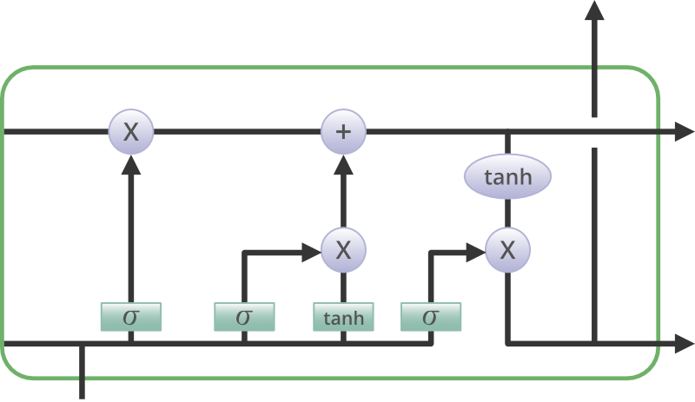
Information is retained by the cells and the memory manipulations are done by the gates. There are three gates –

Forget Gate
The information that is no longer useful in the cell state is removed with the forget gate. Two inputs xt (input at the particular time) and ht-1 (previous cell output) are fed to the gate and multiplied with weight matrices followed by the addition of bias. The resultant is passed through an activation function which gives a binary output. If for a particular cell state the output is 0, the piece of information is forgotten and for output 1, the information is retained for future use. The equation for the forget gate is:
where:
- W_f represents the weight matrix associated with the forget gate.
- [h_t-1, x_t] denotes the concatenation of the current input and the previous hidden state.
- b_f is the bias with the forget gate.
- σ is the sigmoid activation function.
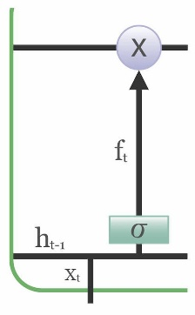

Input gate
The addition of useful information to the cell state is done by the input gate. First, the information is regulated using the sigmoid function and filter the values to be remembered similar to the forget gate using inputs ht-1 and xt. . Then, a vector is created using tanh function that gives an output from -1 to +1, which contains all the possible values from ht-1 and xt. At last, the values of the vector and the regulated values are multiplied to obtain the useful information. The equation for the input gate is:
We multiply the previous state by ft, disregarding the information we had previously chosen to ignore. Next, we include it∗Ct. This represents the updated candidate values, adjusted for the amount that we chose to update each state value.
where
- ⊙ denotes element-wise multiplication
- tanh is tanh activation function
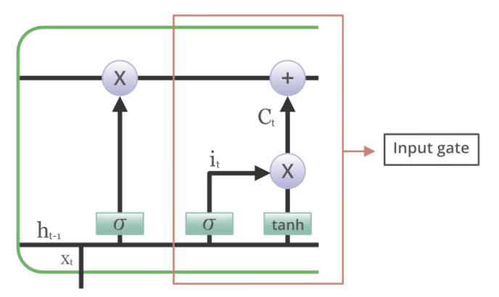

Output gate
The task of extracting useful information from the current cell state to be presented as output is done by the output gate. First, a vector is generated by applying tanh function on the cell. Then, the information is regulated using the sigmoid function and filter by the values to be remembered using inputs ht-1 and xt. At last, the values of the vector and the regulated values are multiplied to be sent as an output and input to the next cell. The equation for the output gate is:
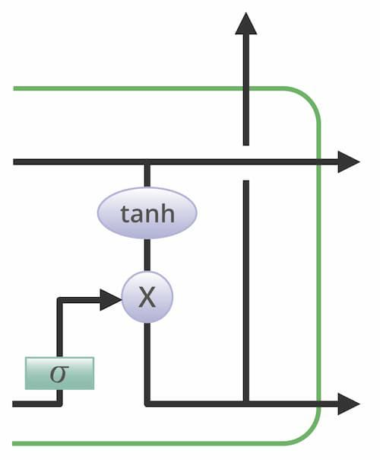
Temporal Convolutional Network (TCN)
Traditional Recurrent Neural Networks (RNNs) and their variants like LSTMs or GRUs are commonly used for sequence modeling. However, they process inputs sequentially, which makes training slow and limits parallelization. Temporal Convolutional Networks (TCNs) address this problem by replacing recurrence with convolutional operations over the temporal dimension.
TCNs are designed for sequence modeling tasks such as speech recognition, time series forecasting, anomaly detection, and natural language processing. Instead of depending on hidden states carried forward in time, TCNs use causal convolutions and dilated convolutions to capture both short-term and long-term dependencies efficiently.

Key Properties of TCN
- Causal Convolution
  - Ensures that the output at time step t only depends on the inputs from time t and earlier, preventing information leakage from the future.
- Dilated Convolution
  - Introduces gaps (dilations) between filter elements, allowing the receptive field to grow exponentially with depth, while keeping the number of parameters manageable.
- Residual Connections
  - TCNs employ residual and skip connections, which help stabilize deep networks and improve gradient flow.
- Parallelism
  - Unlike RNNs that require sequential computation, TCNs allow for parallel processing, making them faster to train.
- Long-Term Dependency Modeling
  - The combination of dilations and stacked layers allows TCNs to effectively capture long-term dependencies in sequential data.

Architecture and Working of TCN
The architecture of a TCN generally includes the following components:
- 1D Causal Convolutional Layers: Perform convolution operations across the temporal dimension without looking into the future.
- Dilated Convolution Layers: Expand the receptive field exponentially by skipping inputs at certain intervals.
- Residual Blocks: Each block contains dilated causal convolutions, weight normalization, activation (ReLU), and residual connections to stabilize training.
- Fully Connected Output Layer: Maps the extracted temporal features to predictions.
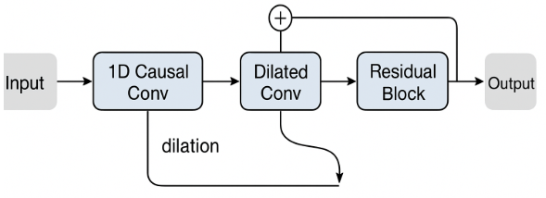
Advantages of TCN
- Faster training due to parallelism.
- Stable gradients compared to RNNs/LSTMs.
- Scalable receptive field with dilated convolutions.
- Outperforms RNN-based models in many sequence modeling benchmarks.
- Robust to noise and effective for time-series tasks.
5.2 Sample Code:
ExplainableIDS.py
from tkinter import messagebox
from tkinter import *
from tkinter import simpledialog
import tkinter
from tkinter import filedialog
import matplotlib.pyplot as plt
from tkinter.filedialog import askopenfilename
import numpy as np
import os
import pandas as pd
from sklearn.preprocessing import LabelEncoder
import seaborn as sns
from sklearn.metrics import precision_score
from sklearn.metrics import recall_score
from sklearn.metrics import f1_score
from sklearn.metrics import confusion_matrix
from sklearn.metrics import accuracy_score
from sklearn.model_selection import train_test_split
from keras.models import Sequential, load_model
import pickle
from keras.layers import Dense, Dropout, Activation, Flatten, LSTM
import os
from keras.models import Model
from sklearn.preprocessing import StandardScaler
from keras.callbacks import ModelCheckpoint
from keras.utils.np_utils import to_categorical
from tcn import compiled_tcn #loading TCN model
from sklearn.ensemble import RandomForestClassifier
import shap
from sklearn.metrics import roc_curve
from sklearn.metrics import roc_auc_score
from sklearn import metrics

main = tkinter.Tk()
main.title("Explainable AI for Intrusion Detection Systems: LIME and SHAP Applicability on Multi-Layer Perceptron")
main.geometry("1300x1200")

global filename, lstm_model, tcn_model, X, Y
global accuracy, precision, recall, fscore, perturb, features
global X_train, X_test, y_train, y_test
global labels
global label_encoder, scaler, shap_values

def upload():
global filename, labels, dataset
filename = filedialog.askopenfilename(initialdir="Dataset")
text.delete('1.0', END)
text.insert(END,filename+" loaded\n")
dataset = pd.read_csv(filename)
text.insert(END,str(dataset)+"\n\n")
text.update_idletasks()
labels = np.unique(dataset["Label"])
label = dataset.groupby('Label').size()
label.plot(kind="bar")
plt.xlabel("Data Type")
plt.ylabel("Count")
plt.title("Normal & Attack Graph")
plt.show()

def preprocess():
text.delete('1.0', END)
global dataset, X, Y, label_encoder, scaler
global X_train, X_test, y_train, y_test, perturb, features
label_encoder = []
columns = dataset.columns
types = dataset.dtypes.values
for j in range(len(types)):
name = types[j]
if name == 'object': #finding column with object type
le = LabelEncoder()
dataset[columns[j]] = pd.Series(le.fit_transform(dataset[columns[j]].astype(str)))#encode all str columns to numeric
label_encoder.append([columns[j], le])
dataset.fillna(0, inplace = True)
dataset = dataset[np.isfinite(dataset).all(1)]
perturb = dataset['FlowDuration'].ravel()
Y = dataset['Label'].ravel()
dataset.drop(['Label', 'FlowDuration'], axis = 1,inplace=True)
features = dataset.columns
X = dataset.values
scaler = StandardScaler()
X = scaler.fit_transform(X)
Y = to_categorical(Y)
text.insert(END,"Processed & Normalized Dataset Features = "+str(X))

def trainTestSplit():
text.delete('1.0', END)
global X, Y, X_train, X_test, y_train, y_test, perturb, features
X = np.reshape(X, (X.shape[0], X.shape[1], 1))
X_train, X_test, y_train, y_test = train_test_split(X, Y, test_size=0.2)
for i in range(0, 10):
X_test[i,0] = perturb[i]
text.insert(END,"Total records found in dataset : "+str(X.shape[0])+"\n\n")
text.insert(END,"Dataset split for train and test\n\n")
text.insert(END,"80% dataset records used to train Algorithms : "+str(X_train.shape[0])+"\n")
text.insert(END,"20% dataset records used to test Algorithms : "+str(X_test.shape[0])+"\n")

#function to calculate all metrics
def calculateMetrics(algorithm, testY, predict):
global labels
p = precision_score(testY, predict,average='macro') * 100
r = recall_score(testY, predict,average='macro') * 100
f = f1_score(testY, predict,average='macro') * 100
a = accuracy_score(testY,predict)*100
accuracy.append(a)
precision.append(p)
recall.append(r)
fscore.append(f)
text.insert(END,algorithm+" Accuracy : "+str(a)+"\n")
text.insert(END,algorithm+" Precision : "+str(p)+"\n")
text.insert(END,algorithm+" Recall : "+str(r)+"\n")
text.insert(END,algorithm+" FSCORE : "+str(f)+"\n\n")
conf_matrix = confusion_matrix(testY, predict)
fig, axs = plt.subplots(1,2,figsize=(10, 4))
ax = sns.heatmap(conf_matrix, xticklabels = labels, yticklabels = labels, annot = True, cmap="viridis" ,fmt ="g", ax=axs[0]);
ax.set_ylim([0,len(labels)])
axs[0].set_title(algorithm+" Confusion matrix")

random_probs = [0 for i in range(len(testY))]
p_fpr, p_tpr, _ = roc_curve(testY, random_probs, pos_label=1)
plt.plot(p_fpr, p_tpr, linestyle='--', color='orange',label="True classes")
ns_fpr, ns_tpr, _ = roc_curve(testY, predict, pos_label=1)
axs[1].plot(ns_fpr, ns_tpr, linestyle='--', label='Predicted Classes')
axs[1].set_title(algorithm+" ROC AUC Curve")
axs[1].set_xlabel('False Positive Rate')
axs[1].set_ylabel('True Positive rate')
plt.show()

def runLSTM():
text.delete('1.0', END)
global accuracy, precision, recall, fscore
accuracy = []
precision = []
recall = []
fscore = []
global X, Y, X_train, X_test, y_train, y_test, labels, lstm_model
lstm_model = Sequential()#defining deep learning sequential object
#adding LSTM layer with 100 filters to filter given input X train data to select relevant features
lstm_model.add(LSTM(32,input_shape=(X_train.shape[1], X_train.shape[2])))
#adding dropout layer to remove irrelevant features
lstm_model.add(Dropout(0.3))
#adding another layer
lstm_model.add(Dense(32, activation='relu'))
#defining output layer for prediction
lstm_model.add(Dense(y_train.shape[1], activation='softmax'))
#compile LSTM model
lstm_model.compile(loss='categorical_crossentropy', optimizer='adam', metrics=['accuracy'])
#start training model on train data and perform validation on test data
#train and load the model
if os.path.exists("model/lstm_weights.hdf5") == False:
model_check_point = ModelCheckpoint(filepath='model/lstm_weights.hdf5', verbose = 1, save_best_only = True)
hist = lstm_model.fit(X_train, y_train, batch_size = 32, epochs = 20, validation_data=(X_test, y_test), callbacks=[model_check_point], verbose=1)
f = open('model/lstm_history.pckl', 'wb')
pickle.dump(hist.history, f)
f.close()
else:
lstm_model.load_weights("model/lstm_weights.hdf5")
#perform prediction on test data
predict = lstm_model.predict(X_test)
predict = np.argmax(predict, axis=1)
y_test1 = np.argmax(y_test, axis=1)
calculateMetrics("LSTM", y_test1, predict)

def runTCN():
global X, Y, X_train, X_test, y_train, y_test, labels, tcn_model
#creating tcn model with number of features and classes
tcn_model = compiled_tcn(return_sequences=False, num_feat=1, num_classes=2, nb_filters=20, kernel_size=6, dilations=[2 ** i for i in range(9)], nb_stacks=1,
max_len=X_train[0:1].shape[1], use_skip_connections=True)
if os.path.exists("model/tcn_weights.hdf5") == False:
model_check_point = ModelCheckpoint(filepath='model/tcn_weights.hdf5', verbose = 1, save_best_only = True)
hist = tcn_model.fit(X_train, y_train.squeeze().argmax(axis=1), epochs = 20, validation_data=(X_test, y_test.squeeze().argmax(axis=1)), callbacks=[model_check_point], verbose=1)
f = open('model/tcn_history.pckl', 'wb')
pickle.dump(hist.history, f)
f.close()
else:
tcn_model.load_weights("model/tcn_weights.hdf5")
predict = tcn_model.predict(X_test)
predict = np.argmax(predict, axis=1)
y_test1 = np.argmax(y_test, axis=1)
calculateMetrics("TCN", y_test1, predict)

def graph():
df = pd.DataFrame([['LSTM','Precision',precision[0]],['LSTM','Recall',recall[0]],['LSTM','F1 Score',fscore[0]],['LSTM','Accuracy',accuracy[0]],
['TCN','Precision',precision[1]],['TCN','Recall',recall[1]],['TCN','F1 Score',fscore[1]],['TCN','Accuracy',accuracy[1]],
],columns=['Parameters','Algorithms','Value'])
df.pivot("Parameters", "Algorithms", "Value").plot(kind='bar')
plt.show()

def predict():
text.delete('1.0', END)
global lstm_model, scaler, label_encoder, labels
filename = filedialog.askopenfilename(initialdir="Dataset")
testdata = pd.read_csv(filename)
temp = testdata.values
for i in range(len(label_encoder)-1):
le = label_encoder[i]
testdata[le[0]] = pd.Series(le[1].transform(testdata[le[0]].astype(str)))#encode all str columns to numeric
testdata.fillna(0, inplace = True)
testdata = testdata[np.isfinite(testdata).all(1)]
testdata.drop(['FlowDuration'], axis = 1,inplace=True)
testdata = scaler.transform(testdata)
testdata = np.reshape(testdata, (testdata.shape[0], testdata.shape[1], 1))
predict = lstm_model.predict(testdata)
predict = np.argmax(predict, axis=1)
for i in range(len(predict)):
text.insert(END,"Test Data = "+str(temp[i][0:15])+" =====> "+labels[predict[i]]+"\n\n")

def explanation():
global features, X_train, X_test, y_train, y_test, shap_values
X_train = np.reshape(X_train, (X_train.shape[0], X_train.shape[1] * X_train.shape[2]))
X_test = np.reshape(X_test, (X_test.shape[0], X_test.shape[1] * X_test.shape[2]))
y_test = np.argmax(y_test, axis=1)
y_train = np.argmax(y_train, axis=1)
rf = RandomForestClassifier()
rf.fit(X_train, y_train)
shap.initjs()
explainer = shap.TreeExplainer(rf, X_test)
# Explain the predictions of your model
shap_values = explainer.shap_values(X_test, check_additivity=False)
# Plot the SHAP values
shap.summary_plot(shap_values[0], feature_names=features, show=True)

def Violinexplanation():
global shap_values, features
#violin plot to explain names of features which is contributing most for the algorithm to make correct prediction
shap.plots.violin(shap_values[0], feature_names=features, show=True)

font = ('times', 16, 'bold')
title = Label(main, text='Explainable AI for Intrusion Detection Systems: LIME and SHAP Applicability on Multi-Layer Perceptron')
title.config(bg='firebrick4', fg='dodger blue')
title.config(font=font)
title.config(height=3, width=120)
title.place(x=0,y=5)

font1 = ('times', 12, 'bold')
text=Text(main,height=24,width=150)
scroll=Scrollbar(text)
text.configure(yscrollcommand=scroll.set)
text.place(x=40,y=120)
text.config(font=font1)

font1 = ('times', 13, 'bold')
uploadButton = Button(main, text="Upload CICIDS Dataset", command=upload, bg='#ffb3fe')
uploadButton.place(x=50,y=600)
uploadButton.config(font=font1)

processButton = Button(main, text="Preprocess Dataset", command=preprocess, bg='#ffb3fe')
processButton.place(x=300,y=600)
processButton.config(font=font1)

splitButton1 = Button(main, text="Train & Test Split", command=trainTestSplit, bg='#ffb3fe')
splitButton1.place(x=550,y=600)
splitButton1.config(font=font1)

lstmButton = Button(main, text="Run LSTM Algorithm", command=runLSTM, bg='#ffb3fe')
lstmButton.place(x=790,y=600)
lstmButton.config(font=font1)

tcnButton = Button(main, text="Run TCN Algorithm", command=runTCN, bg='#ffb3fe')
tcnButton.place(x=990,y=600)
tcnButton.config(font=font1)

graphButton = Button(main, text="Comparison Graph", command=graph, bg='#ffb3fe')
graphButton.place(x=50,y=650)
graphButton.config(font=font1)

explainButton = Button(main, text="Summary Model Explanation", command=explanation, bg='#ffb3fe')
explainButton.place(x=300,y=650)
explainButton.config(font=font1)

explainButton = Button(main, text="Violin Model Explanation", command=Violinexplanation, bg='#ffb3fe')
explainButton.place(x=550,y=650)
explainButton.config(font=font1)

predictButton = Button(main, text="Predict Attack from Test Data", command=predict, bg='#ffb3fe')
predictButton.place(x=790,y=650)
predictButton.config(font=font1)

main.config(bg='LightSalmon3')
main.mainloop()

TESTING
Implementation and Testing:
Implementation is one of the most important tasks in project is the phase in which one has to be cautions because all the efforts undertaken during the project will be very interactive. Implementation is the most crucial stage in achieving successful system and giving the users confidence that the new system is workable and effective. Each program is tested individually at the time of development using the sample data and has verified that these programs link together in the way specified in the program specification. The computer system and its environment are tested to the satisfaction of the user.
Implementation
The implementation phase is less creative than system design. It is primarily concerned with user training, and file conversion. The system may be requiring extensive user training. The initial parameters of the system should be modifies as a result of a programming. A simple operating procedure is provided so that the user can understand the different functions clearly and quickly. The different reports can be obtained either on the inkjet or dot matrix printer, which is available at the disposal of the user. The proposed system is very easy to implement. In general implementation is used to mean the process of converting a new or revised system design into an operational one.
Testing
Testing is the process where the test data is prepared and is used for testing the modules individually and later the validation given for the fields. Then the system testing takes place which makes sure that all components of the system property functions as a unit. The test data should be chosen such that it passed through all possible condition. Actually testing is the state of implementation which aimed at ensuring that the system works accurately and efficiently before the actual operation commence. The following is the description of the testing strategies, which were carried out during the testing period.
System Testing
Testing has become an integral part of any system or project especially in the field of information technology. The importance of testing is a method of justifying, if one is ready to move further, be it to be check if one is capable to with stand the rigors of a particular situation cannot be underplayed and that is why testing before development is so critical. When the software is developed before it is given to user to use the software must be tested whether it is solving the purpose for which it is developed. This testing involves various types through which one can ensure the software is reliable. The program was tested logically and pattern of execution of the program for a set of data are repeated. Thus the code was exhaustively checked for all possible correct data and the outcomes were also checked.

Module Testing
To locate errors, each module is tested individually. This enables us to detect error and correct it without affecting any other modules. Whenever the program is not satisfying the required function, it must be corrected to get the required result. Thus all the modules are individually tested from bottom up starting with the smallest and lowest modules and proceeding to the next level. Each module in the system is tested separately. For example the job classification module is tested separately. This module is tested with different job and its approximate execution time and the result of the test is compared with the results that are prepared manually. The comparison shows that the results proposed system works efficiently than the existing system. Each module in the system is tested separately. In this system the resource classification and job scheduling modules are tested separately and their corresponding results are obtained which reduces the process waiting time.
Integration Testing
After the module testing, the integration testing is applied. When linking the modules there may be chance for errors to occur, these errors are corrected by using this testing. In this system all modules are connected and tested. The testing results are very correct. Thus the mapping of jobs with resources is done correctly by the system.
Acceptance Testing
When that user fined no major problems with its accuracy, the system passers through a final acceptance test. This test confirms that the system needs the original goals, objectives and requirements established during analysis without actual execution which elimination wastage of time and money acceptance tests on the shoulders of users and management, it is finally acceptable and ready for the operation

Test Case Id | Test Case Name | Test Case Desc. | Test Steps |  |  |  | Test Case Status | Test Priority
 |  |  | Step | Expected |  | Actual
1 | Upload CICIDS Dataset | Verify Dataset is uploaded or not | If Dataset May not be Uploaded | we cannot do any further operations | we can do further operations |  | High | High
2 | Pre-process Dataset | Verify Dataset is Pre-processed or not | If Dataset May not be Pre-processed | we cannot do any further operations | we can do further operations |  | High | High
3 | Calculate  Metrics | Verify Metrics is calculated  or not | If Metrics is not calculated | we cannot do any further operations | we can do further operations |  | High | High
4 | Run LSTM Algorithm | Verify  LSTM Models is trained or not | If LSTM Models may not be trained | we cannot do any further operations | we can do further operations |  | High | High
5 | Run TCN Algorithm | Verify  TCN Models is trained or not | If TCN Models may not be trained | we cannot do any further operations | we can do further operations |  | High | High
6 | Summary Model Explanation | Verify Summary Model Explanation is properly working or not | If Summary Model Explanation may not working properly | we cannot do any further operations | we can do further operations |  | High | High
7 | Violin Model Explanation | Verify Summary Model Explanation is properly working or not | If Summary Model Explanation may not working properly | we cannot do any further operations | we can do further operations |  | High | High
8 | Predict | Verify Predict is properly working or not | If Predict may not working properly | we cannot do any further operations | we can do further operations |  | High | High

7.SCREENSHOTS:
To run project double click on ‘run.bat’ file to get below screen
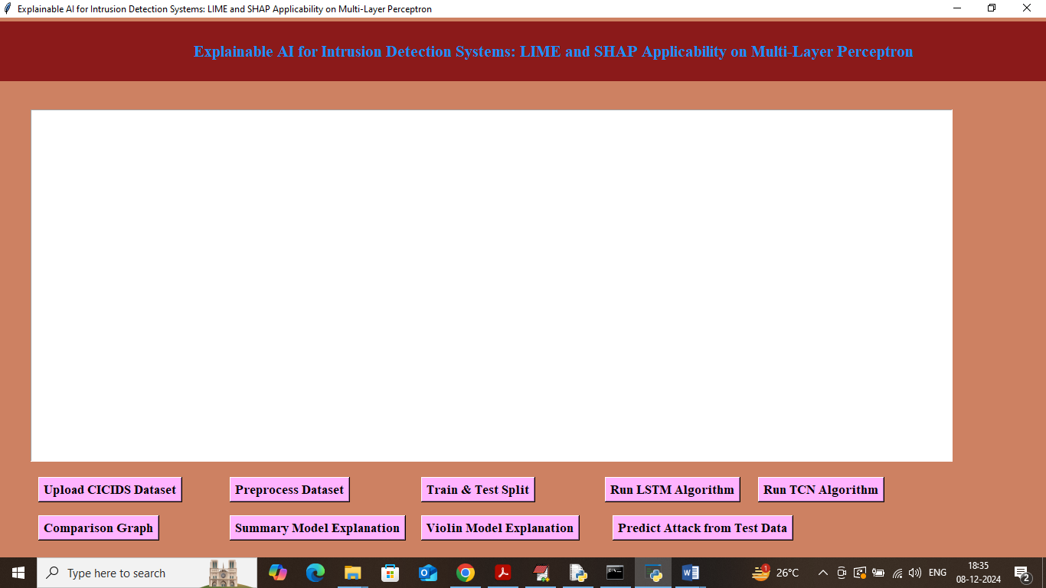
In above screen click on ‘Upload CICIDS Dataset’ button to load dataset and get below output
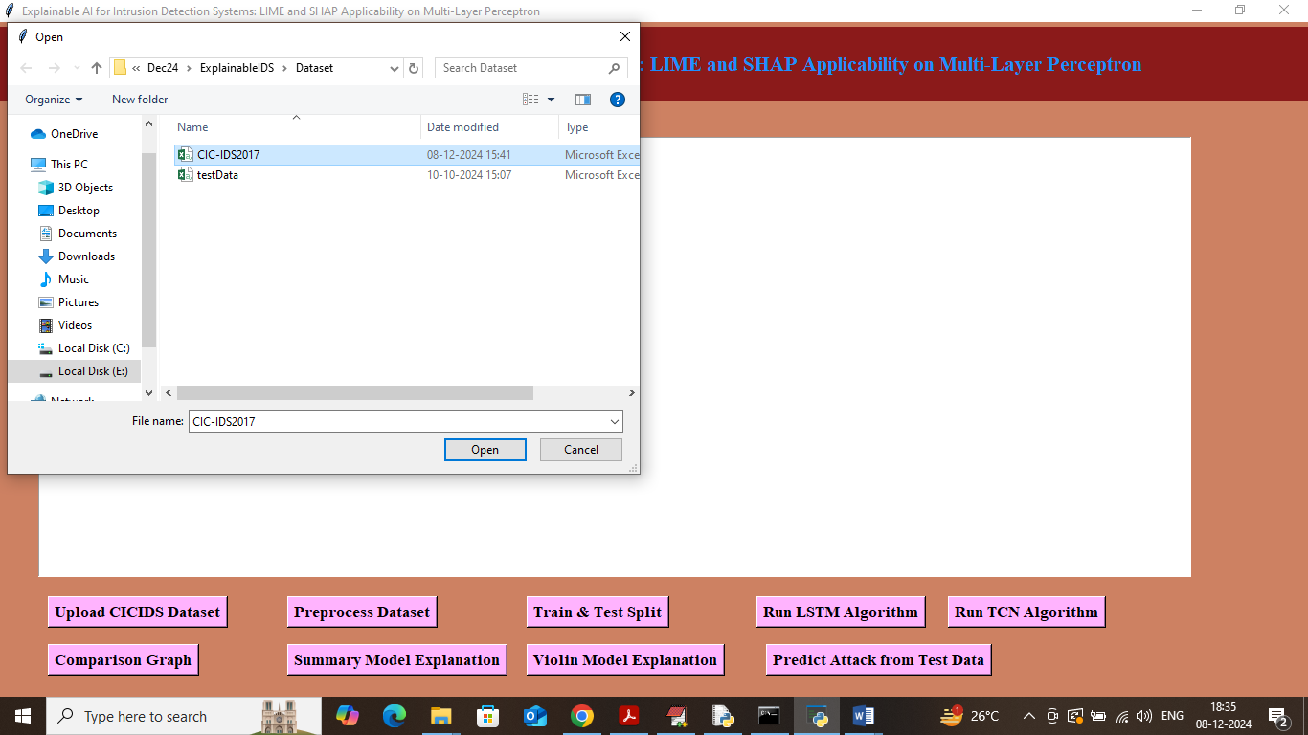
In above screen selecting and uploading CICIDS dataset and then click on ‘Open’ button to load dataset and get below output
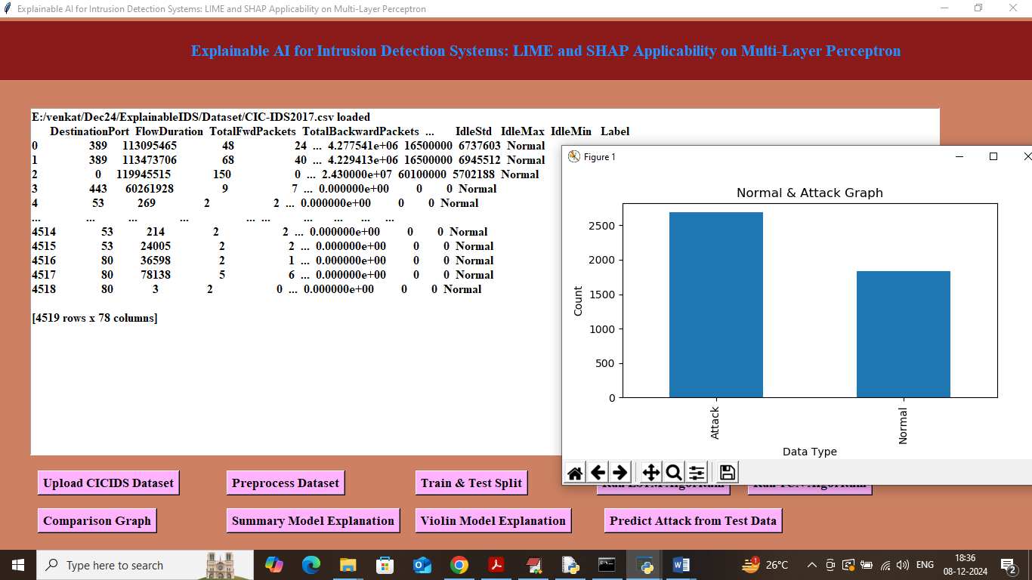
In above screen dataset loaded and in graph x-axis represents Normal and Attack label and y-axis represents number of records and in above dataset values we can see some are non-numeric and some are numeric and machine learning algorithms accept only numeric values so we need to process dataset to encode non-numeric values to numeric values so click on ‘Pre-process Dataset’ button to get below output
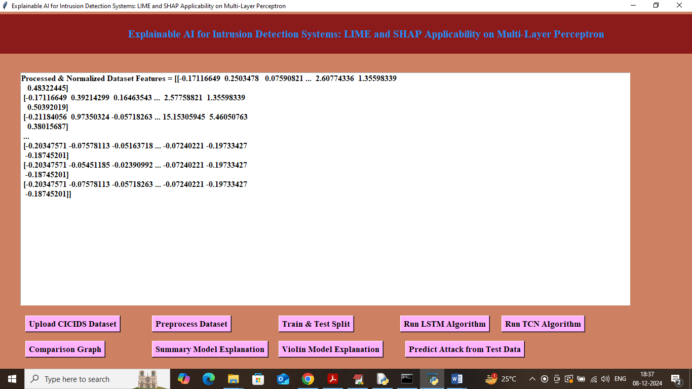
In above screen we can see all values are converted to numeric format and then all values are normalized using Standard Scaler algorithm. Now click on ‘Train & Test Split’ button to split dataset into train and test and then will get below output
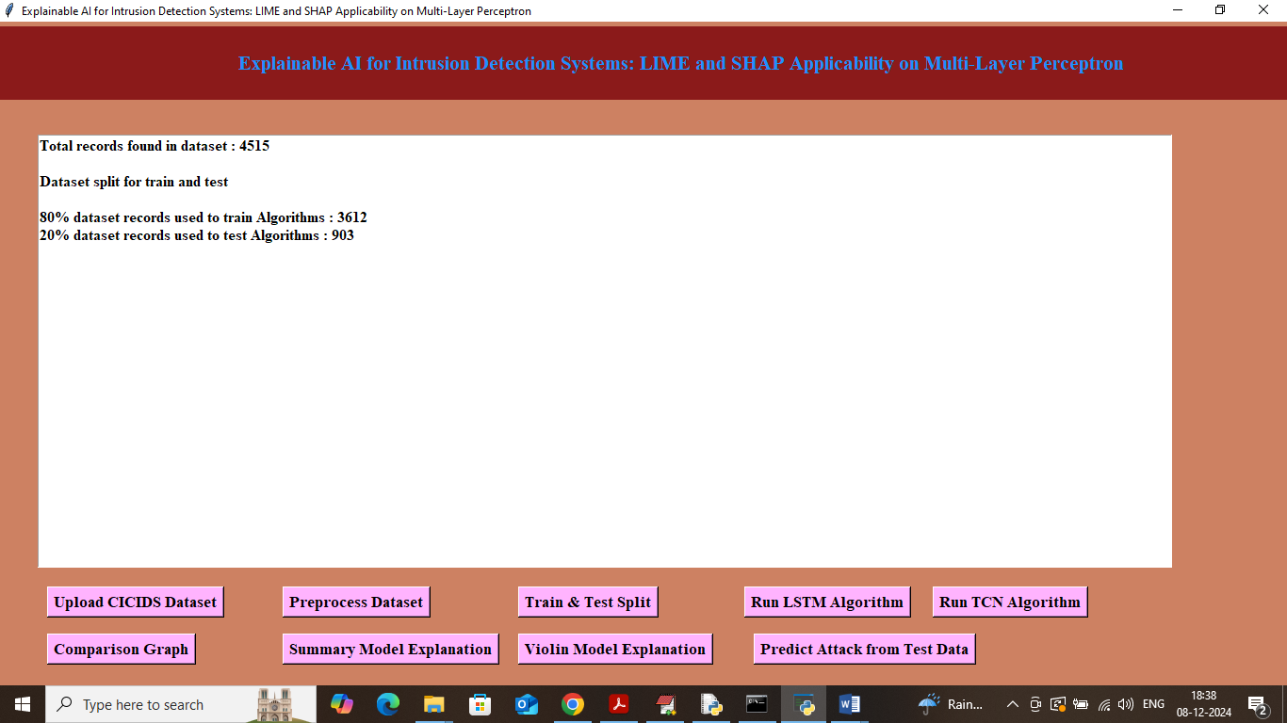
In above screen can see dataset contains 4515 records where application using 80% records (3612) for training and 903 (20%) records for testing. Now click on ‘Run LSTM Algorithm’ button to train LSTM on 80% dataset and test on 20% data to get below prediction accuracy
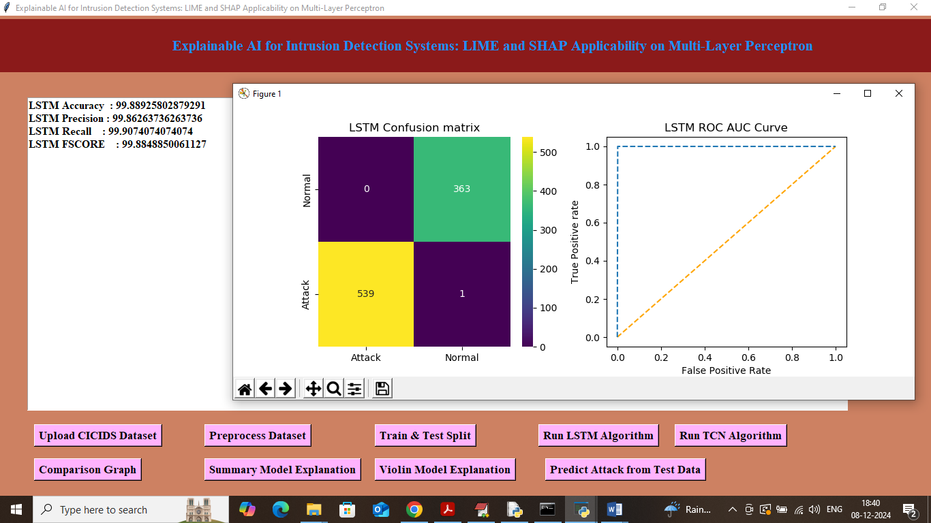
In above screen with LSTM we got 99.88% accuracy and we can see other metrics like precision, recall and FSCORE. In confusion matric graph x-axis represents Predicted Labels and y-axis represents True Labels and then yellow and greencolour boxes in diagonal represents correct prediction and remaining blue boxes contains incorrect prediction count. In ROC curve graph x-axis represents False Positive Rate and Y-axis represents True Positive Rate and if blue line comes on top of orange line then all predictions are correct and if goes below orange line then predictions are incorrect. Now close above graph and then click on ‘Run TCN Algorithm’ button to get below output
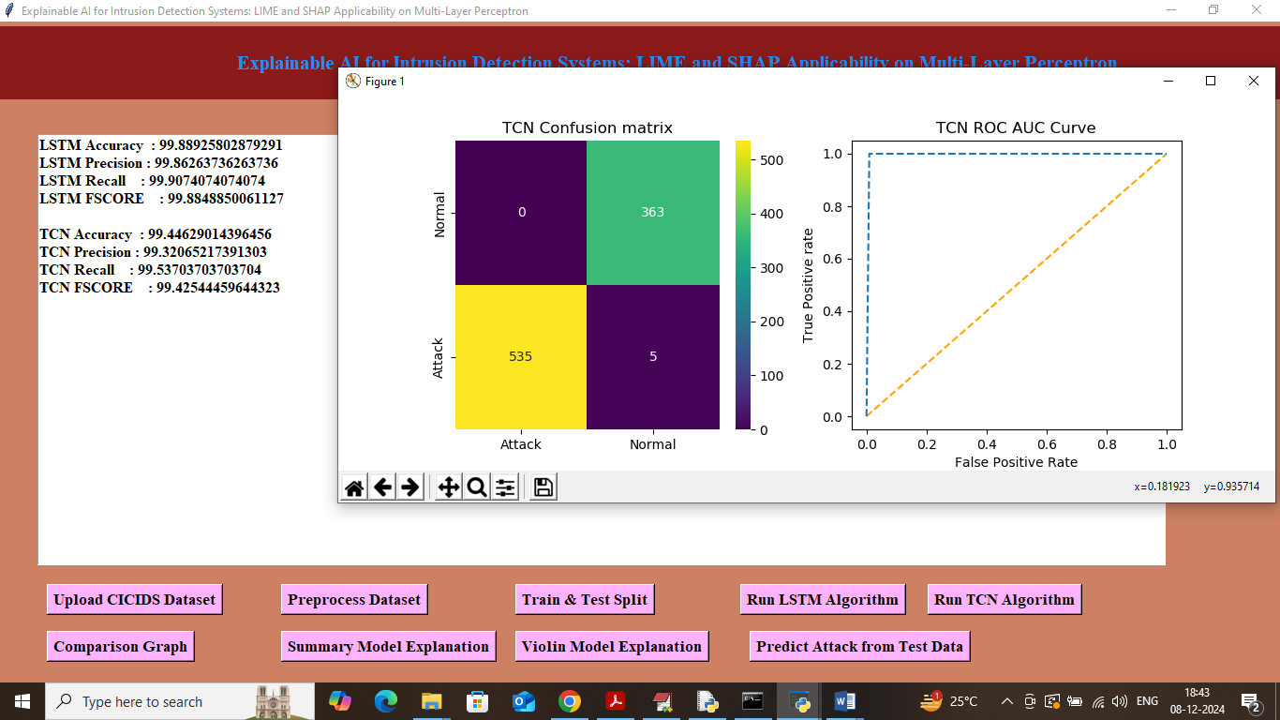
In above screen TCN got 99.44% accuracy and can see other metrics also. Now click on ‘Comparison Graph’ button to get below output
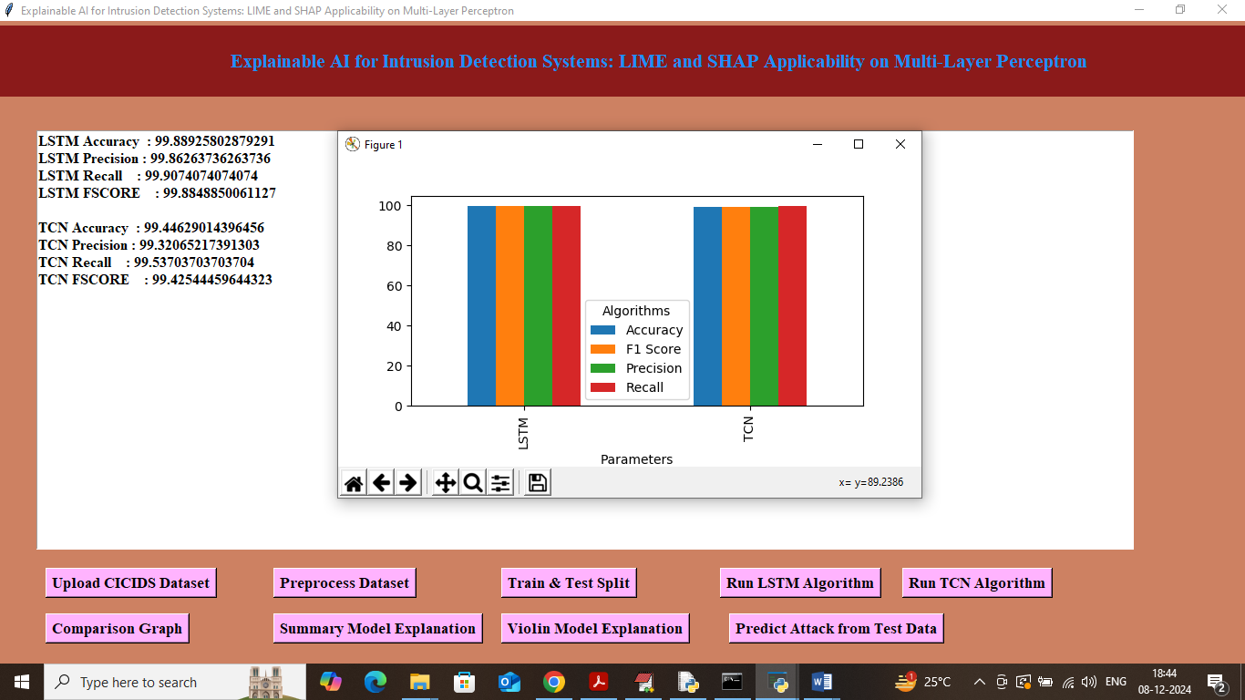
In above graph x-axis represents algorithm names and y-axis represents metric values like accuracy, precision, recall in different bar colour and in all algorithms LSTM got high accuracy. Now close above graph and then click on ‘Summary Model Explanation’ to get below explanation graph from SHAP
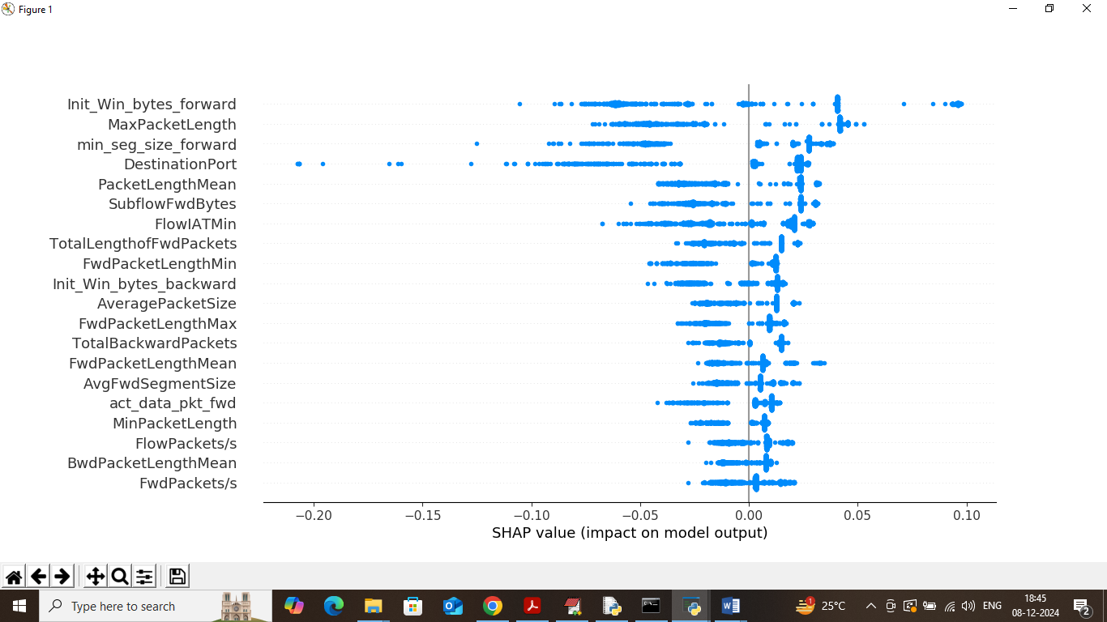
In above summary plot explanation graph we can see features names at left hand side and then blue dots represents percentage of that features contribution. In above graph features with more dots contributing most to model in prediction. Now click on ‘Violin Model Explanation’ button to get below explanation
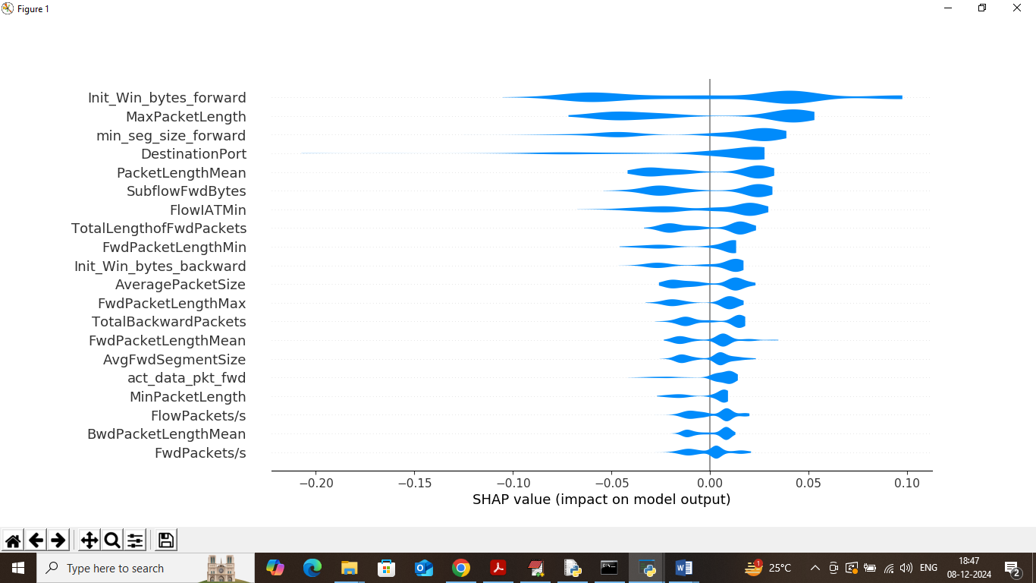
Above violin graph also explain which features is contributing most for correct class label prediction. Now click on ‘Predict Attack from Test Data’ button to upload test data and get below page
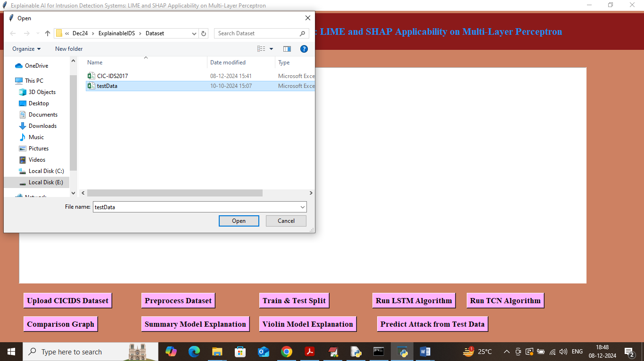
In above screen selecting and uploading testData.csv file and then click on ‘Open’ button to get below output
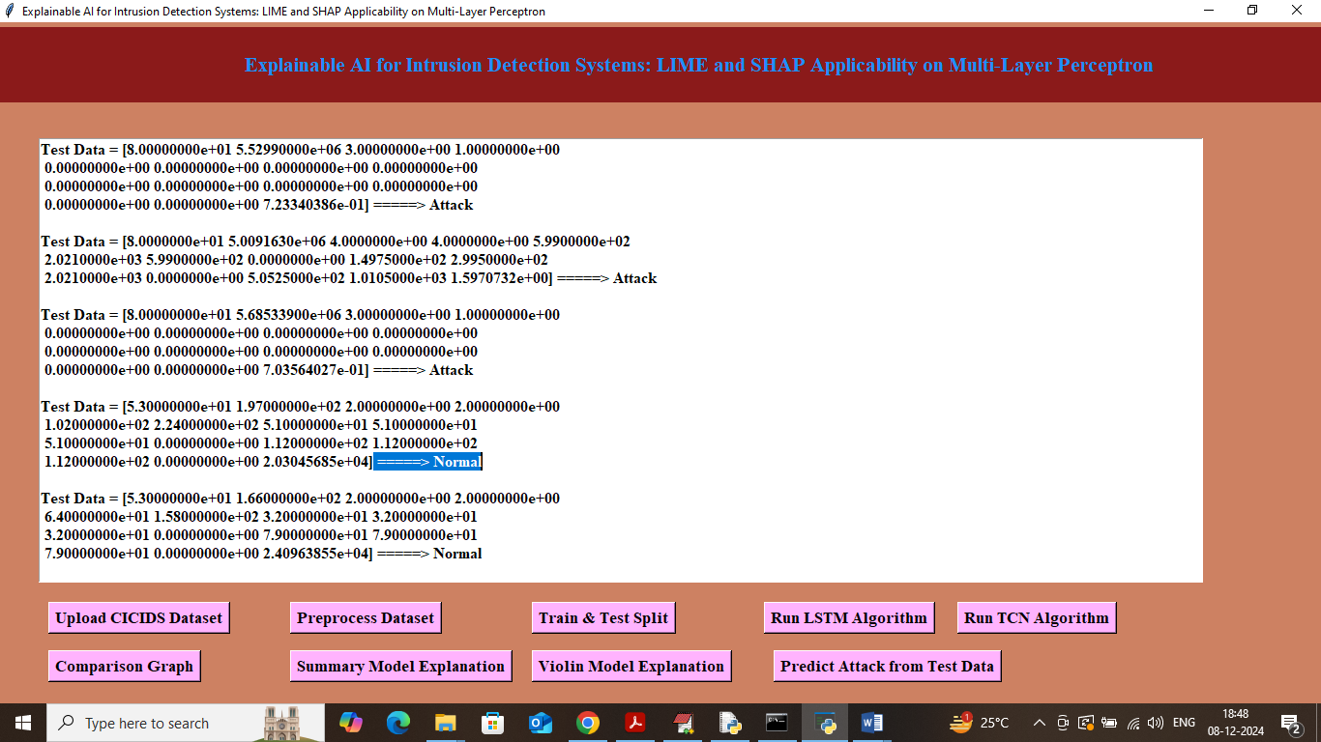
In above screen in square bracket we can see test data values and after arrow symbol can see predicted output as Normal or Attack.
Conclusion:
This project demonstrates the successful application of deep learning models—LSTM and TCN—for intrusion detection using the CIC-IDS dataset. Both models achieved exceptional accuracy (above 98%) even under perturbed test conditions, showcasing robustness and reliability. Among them, LSTM slightly outperformed TCN in most evaluation metrics. More importantly, the integration of SHAP-based explanations provided transparency into the decision-making process, identifying key features responsible for predictions and enhancing trust in model outcomes. By combining high accuracy with explainability, this research offers a practical and trustworthy framework for modern intrusion detection systems.

Future Scope:
- Extend the study to incorporate additional deep learning models such as CNN-LSTM hybrids, Transformers, or Graph Neural Networks.
- Implement real-time IDS deployment in enterprise networks for live traffic monitoring and defense.
- Enhance explainability by integrating more advanced XAI tools beyond SHAP and LIME, such as Counterfactual Explanations or Anchors.
- Expand the dataset to include multi-source traffic data for improved generalizability.
- Develop a cloud-based or distributed IDS framework for large-scale network environments.
REFERENCES:
- Gharib, W., & Zulkernine, M. (2020). Deep learning for intrusion detection systems: A survey and taxonomy. Computer Science Review.
- Sharafaldin, I., Lashkari, A. H., & Ghorbani, A. A. (2018). Toward generating a new intrusion detection dataset and intrusion traffic characterization. ICISSP.
- Kim, J., & Kim, H. (2019). Applying LSTM to anomaly detection in network traffic. ICT Express.
- Bai, S., Kolter, J. Z., & Koltun, V. (2018). An empirical evaluation of generic convolutional and recurrent networks for sequence modeling. arXiv preprint.
- Shapley, L. S. (1953). A value for n-person games. Contributions to the Theory of Games.
- Lundberg, S. M., & Lee, S. I. (2017). A unified approach to interpreting model predictions. NeurIPS.
- Ribeiro, M. T., Singh, S., & Guestrin, C. (2016). “Why should I trust you?” Explaining the predictions of any classifier. KDD.
- Roy, S., & Cheung, R. C. (2020). Explainable AI in cybersecurity. IEEE Security & Privacy.
- Ring, M., Wunderlich, S., Grüdl, D., Landes, D., & Hotho, A. (2019). Flow-based network traffic generation using generative adversarial networks. Computers & Security.
- Javaid, A., Niyaz, Q., Sun, W., & Alam, M. (2016). A deep learning approach for network intrusion detection system. EAI Transactions.
- Sommer, R., & Paxson, V. (2010). Outside the closed world: On using machine learning for network intrusion detection. IEEE S&P.
- Zhao, Y., Chen, Z., & Xie, J. (2021). Network intrusion detection using transformer models. Information Sciences.
- Yan, C., Xu, Y., & Wu, J. (2018). Network intrusion detection based on deep learning. Proceedings of DSAA.
- Alshamrani, A., Myneni, S., Chowdhary, A., & Huang, D. (2019). A survey on advanced persistent threats: Techniques, solutions, challenges, and research opportunities. IEEE Communications Surveys & Tutorials.
- Ding, S., Xu, X., & Nie, R. (2020). Intrusion detection system based on feature selection and ensemble classifier. International Journal of Information Security.
- Zhang, J., & Zulkernine, M. (2021). Explainable deep learning in network intrusion detection: A review. IEEE Access.
- Moustafa, N., & Slay, J. (2015). UNSW-NB15: A comprehensive dataset for network intrusion detection. Military Communications and Information Systems Conference.
- Lopez-Martin, M., Carro, B., & Sanchez-Esguevillas, A. (2017). Application of deep reinforcement learning to intrusion detection. ICANN.
- Khraisat, A., Gondal, I., Vamplew, P., & Kamruzzaman, J. (2019). Survey of intrusion detection systems: techniques, datasets, and challenges. Cybersecurity Journal.
- Yu, Y., & Long, J. (2022). Enhancing intrusion detection with explainable AI: A case study using SHAP. Applied Sciences.

